Software Testing Assignment Module 3

(Testing on Live Application)

**--------------------------------------------------------------------------------------------------------------------------------------**

# **What is RDBMS**

A database management system (or DBMS) is essentially nothing more than a computerized data-keeping system.

Database Management System (DBMS) is software used to identify, manage, and create a database that provides administered access to the data.

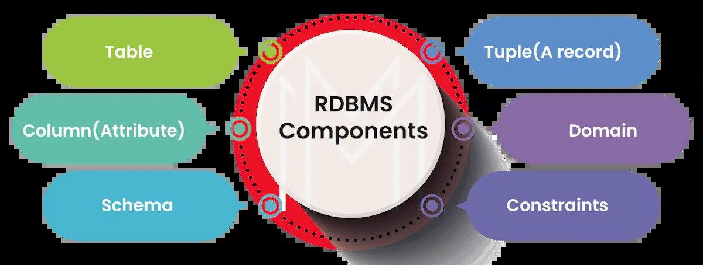

# **What is SQL**

SQL (Structured Query Language) is a programming language used to manage and manipulate data stored in relational database management systems (RDBMS). To use SQL in: MySQL, SQL Server, MS Access, Oracle, Sybase, Informix, Postgres, and other database systems.

# **Write SQL Commands**

Data Definition Language (DDL)

1. CREATE TABLE table_name (column1 datatype, column2 datatype, ...);
2. ALTER TABLE table_name ADD column_name datatype;
3. DROP TABLE table_name;
4. TRUNCATE TABLE table_name;
5. CREATE INDEX index_name ON table_name (column_name);

Data Manipulation Language (DML)

1. INSERT INTO table_name (column1, column2, ...) VALUES (value1, value2, ...);
2. UPDATE table_name SET column1 = value1, column2 = value2 WHERE condition;
3. DELETE FROM table_name WHERE condition;

Data Query Language (DQL)

1. SELECT column1, column2, ... FROM table_name WHERE condition;
2. SELECT * FROM table_name WHERE condition;
3. SELECT column1, column2, ... FROM table_name ORDER BY column_name ASC/DESC;

Data Control Language (DCL)

1. GRANT privilege ON table_name TO user_name;
2. REVOKE privilege ON table_name FROM user_name;

Transaction Control Language (TCL)

1. BEGIN TRANSACTION;
2. COMMIT;
3. ROLLBACK;

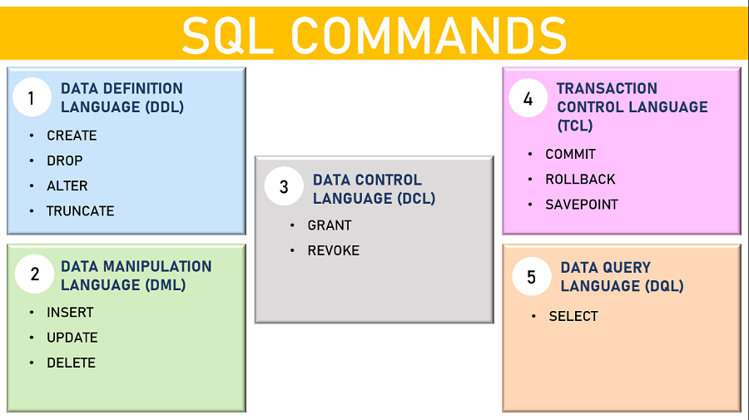

# **What is join?**

In SQL, a JOIN is a clause that combines rows from two or more tables based on a related column between them. It allows you to retrieve data from multiple tables in a single query.

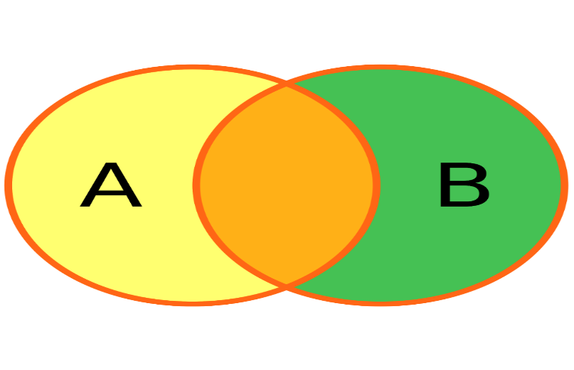

# **Write type of joins.**

There are several types of JOINs:

1. **INNER JOIN:** Returns only the rows that have a match in both tables.
2. **LEFT JOIN (or LEFT OUTER JOIN):** Returns all the rows from the left table and the matched rows from the right table.
3. **RIGHT JOIN (or RIGHT OUTER JOIN):** Returns all the rows from the right table and the matched rows from the left table.
4. **FULL JOIN (or FULL OUTER JOIN):** Returns all the rows from both tables, with NULL values in the columns where there are no matches.
5. **CROSS JOIN:** Returns the Cartesian product of both tables, with each row of one table combined with each row of the other table.

# **How Many constraint and describes it self**

There are 7 types of constraints in SQL:

1. **Primary Key (PK) Constraint:** Ensures that each row has a unique identifier. No two rows can have the same primary key value.
2. **Foreign Key (FK) Constraint:** Ensures that the value in a column matches the primary key value in another table.
3. **Unique Constraint:** Ensures that all values in a column are unique.
4. **Not Null Constraint:** Ensures that a column cannot have a null value.
5. **Check Constraint:** Ensures that the values in a column meet a specific condition or rule.
6. **Default Constraint:** Automatically assigns a default value to a column when no value is specified.
7. **Create Index:** Used to create and retrieve data from the database very quickly

These constraints help maintain data integrity and accuracy by enforcing rules and relationships between data in a database.

# **Difference between RDBMS vs DBMS**

|  |  |
| --- | --- |
| **RDMS** | **DBMS** |
| Data is stored in table format. | Data is stored in file format. |
| Multiple data elements are accessible together | Individual access of data elements |
| Data in the form of a table are linked together | No connection between data |
| Support distributed database | No support for distributed database |
| Data is stored in a large amount | Data stored is a small quantity |
| RDBMS supports multiple users | DBMS supports a single user |

# **What is API Testing**

API testing is the process of verifying that an application programming interface (API) meets its functional and performance requirements. It involves testing the API's inputs, outputs, and behavior to ensure it works as expected.

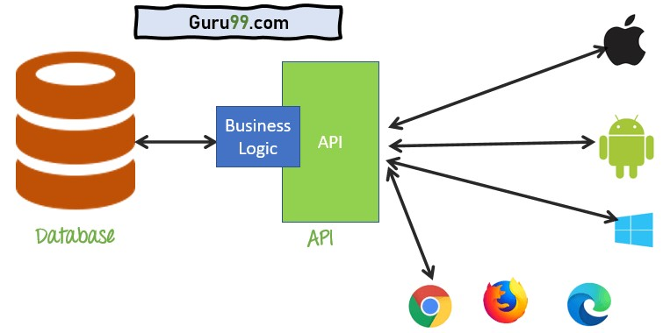

# **Types of API Testing**

Mainly 3 types of API Testing

1. **Open APIs:** These types of APIs are publicly available to use like OAuth APIs from Google. It has also not given any restriction to use them. So, they are also known as Public APIs.
2. **Partner APIs:** Specific rights or licenses to access this type of API because they are not available to the public.
3. **Internal APIs:** Internal or private. These APIs are developed by companies to use in their internal systems. It helps you to enhance the productivity of your teams.

# **What is Responsive Testing?**

Responsive testing is a type of testing that ensures a website, web application, or mobile application adapts correctly to various screen sizes, devices, and orientations. It involves testing the application's responsiveness, usability, and functionality across different devices, browsers, and screen resolutions.

1. **Device testing:** Testing on various devices, such as smartphones, tablets, laptops, and desktops.
2. **Screen size testing:** Testing on different screen sizes and resolutions.
3. **Orientation testing:** Testing in portrait and landscape modes.
4. **Browser testing:** Testing on various browsers, such as Chrome, Firefox, Safari, and Edge.
5. **Operating System (OS) testing:** Testing on different OS versions, such as Windows, macOS, Android, and iOS.



# **What is the full form of .ipa, .apk**

The full forms are:

* **.ipa:** iOS App Store Package (or iOS Package Archive)
* **.apk:** Android Package Kit (or Android Application Package)

These are file formats used to distribute and install applications on mobile devices:

* **.ipa** files are used for iOS devices (iPhone, iPad, iPod touch)
* **.apk** files are used for Android devices (smartphones, tablets, etc.)

These files contain the application code, resources, and metadata needed to install and run the app on the respective mobile platform.

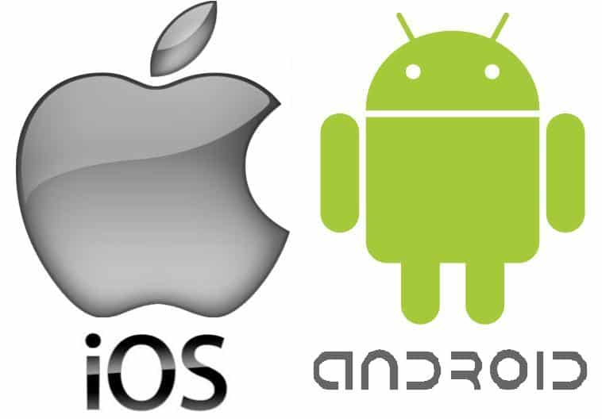

# **How to create step for to open the developer option mode ON?**

To enable Developer Options on an Android device, follow these steps:

* Go to your device's Settings app.
* Scroll down and select About phone or About device.
* Locate the Build number or Software information section.
* Tap on the Build number 7 times in a row. You will see a message that says "You are now a developer!"
* Go back to the main Settings menu.
* Scroll down and select Developer options.
* Toggle the switch to enable Developer options.

# **How to check developer mode ON or not?**

To check if Developer Options is enabled on your Android device:

* Going to Settings
* Selecting About phone or About device
* Looking for Build number
* If you see a message that says "You are now a developer!" or "Developer mode has been enabled", it means Developer Options is already enabled.